Documents You Need to Get Car Insurance:
- Personal Information
- Vehicle Information
- Driving History
- Current Insurance
- Financial Information- Bank Account details
The Bottom Line
- When shopping for car insurance, you need to provide personal information including your name, address, Social Security number and driver’s license number. You also need your vehicle’s VIN, make, model, year and mileage and the type of coverage you need. Additionally, you need information about your driving history, such as if you’ve had speeding tickets or accidents.
- Once you supply this information, you can receive quotes from providers. If you plan to buy your policy, supply your bank account information for payment and you’ll receive your insurance documents.
What Documents Do You Need to Change Your Insurance Coverage?
- Adding a New Driver
Adding a new driver is similar to when you signed up for your policy. Give your carrier the personal information of the driver you want to add, including their name and address, the vehicle they plan to drive and information about their driving history.
- Adding a New Vehicle
When you buy a new vehicle or trade your existing one in, you’ll need to notify your insurance company. Provide the new vehicle’s VIN, make, model, year and mileage. If you buy at a dealership, you may be asked for a copy of your insurance card before completing the sale. They may contact the carrier or have you do it before letting you drive the vehicle off the lot.
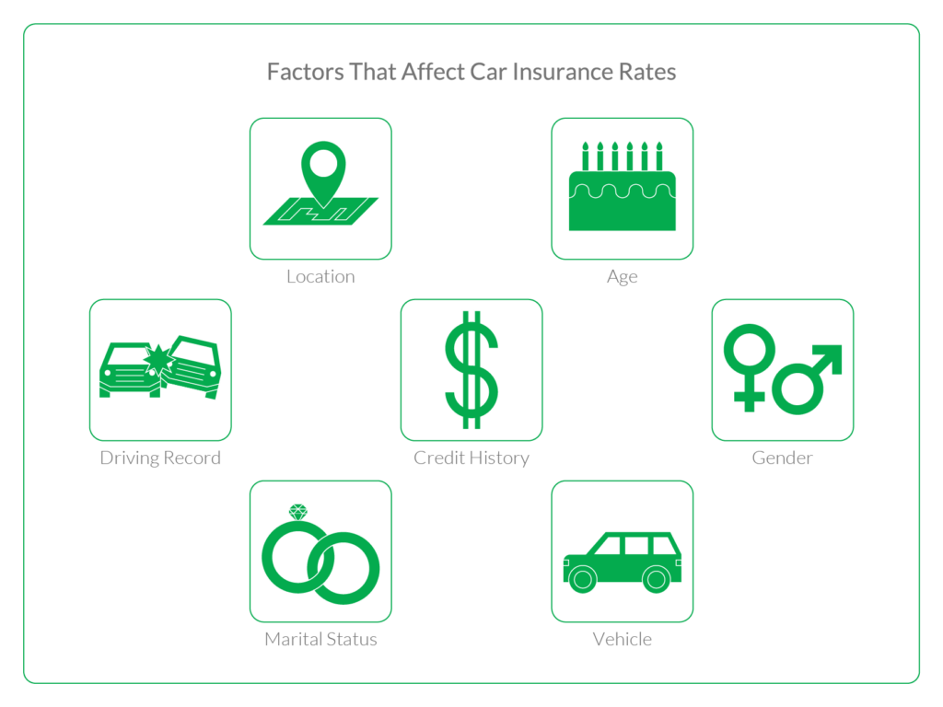
- Some of the factors that may affect your insurance premiums are:
- Location: If you live in an area prone to vehicle break-ins or where there’s a high rate of uninsured motorists, you could pay more for your policy.
- Age: Teen drivers tend to pay more for car insurance in most states because of their inexperience behind the wheel. However, as they approach the age of 25, they’ll usually see lower rates with safe driving behaviours.
- Driving record: Many providers offer discounts to drivers who haven’t been in accidents or received moving violations for the past three to five years.
- Credit history: The higher your credit score, the lower your insurance rates will typically be. However, some states don’t allow providers to check your credit.
- Gender: Women tend to receive lower insurance rates than male drivers, but six states don’t allow gender to be a factor in setting premiums.
- Marital status: Married drivers often pay less for car insurance than single drivers do, but basing rates on marital status isn’t allowed in some states.
- Vehicle: Your motor vehicle’s make; model and year affect how much you pay for insurance. Brands that have higher rates of theft may have more expensive car insurance policies.
- Other things can impact car insurance costs, such as your coverage options. If you only want to meet your state’s minimum insurance requirements, you’ll pay a lower insurance rate. However, liability insurance doesn’t pay for property damage done to your vehicle or for your and your passengers’ medical bills like full coverage could.

